How to deploy work on azure devops

1. Go to azure devops



1. Now go to my azure devops organizations



1. Create new organization

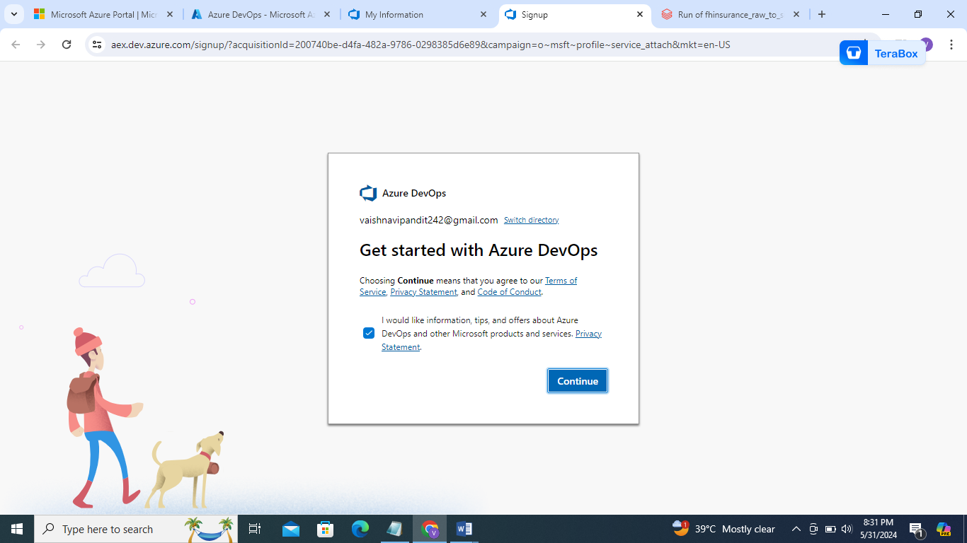

1. Continue

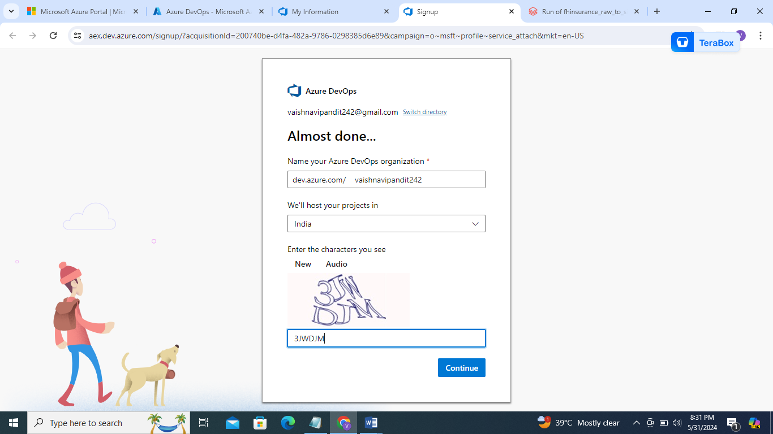

1. Continue

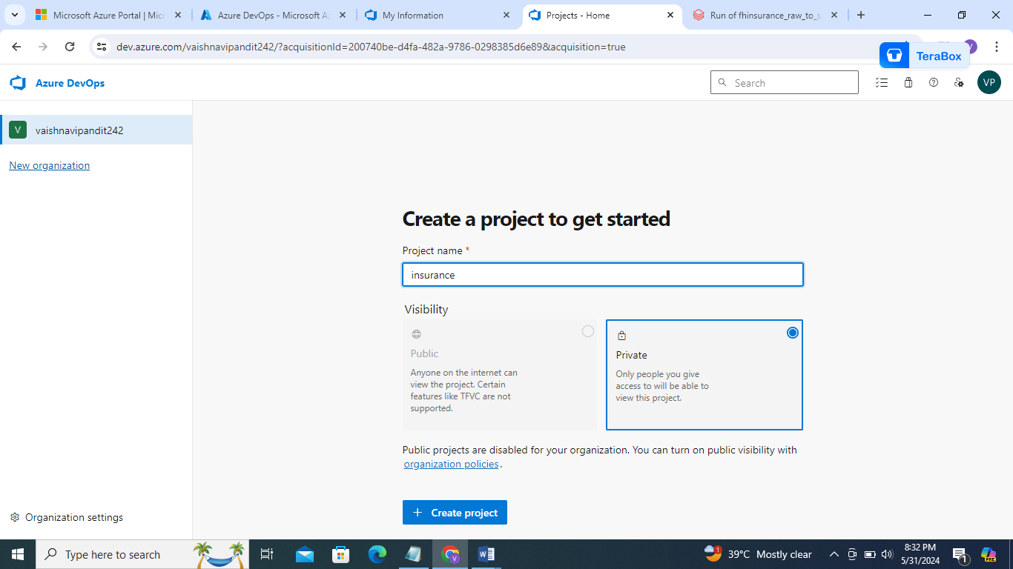

1. Create project

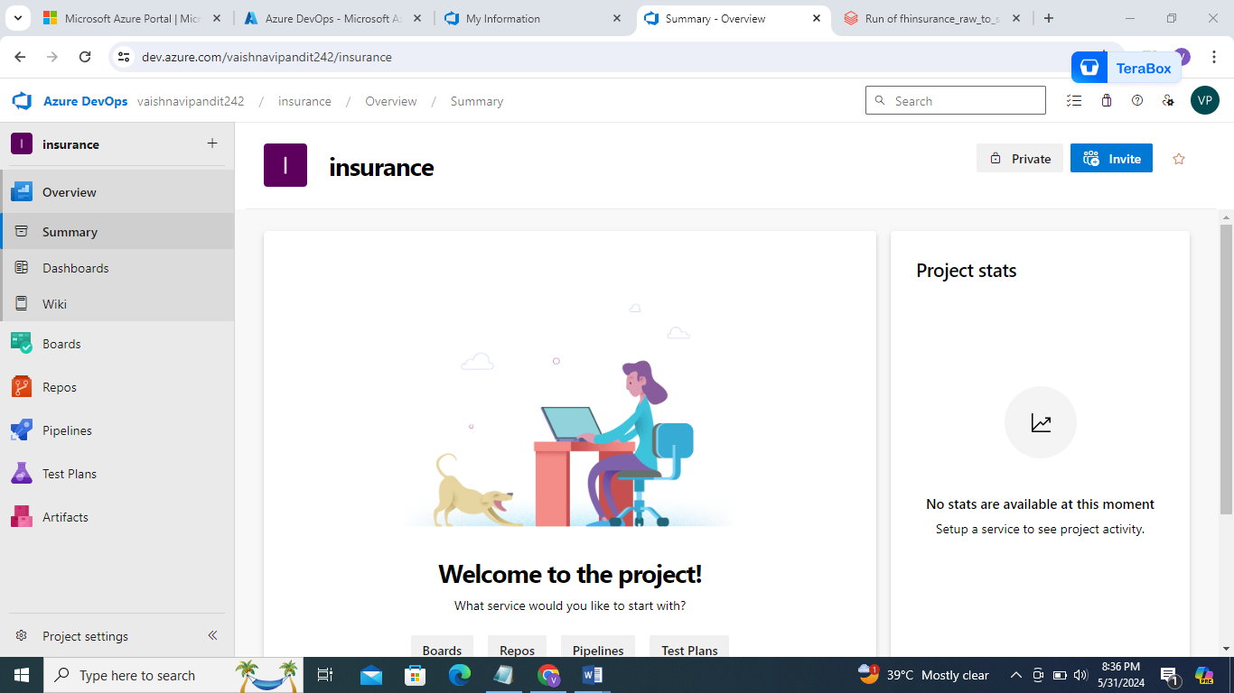

1. Go to boards->workitems->new work irems->add task for to do list
2. Now go to repos

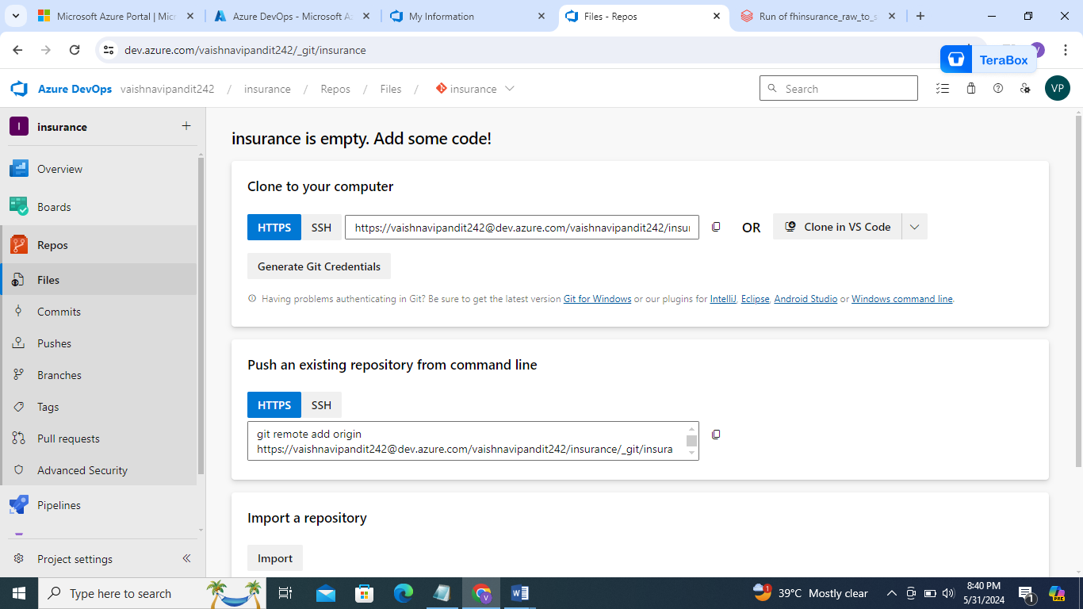

1. Copy clone to computer url

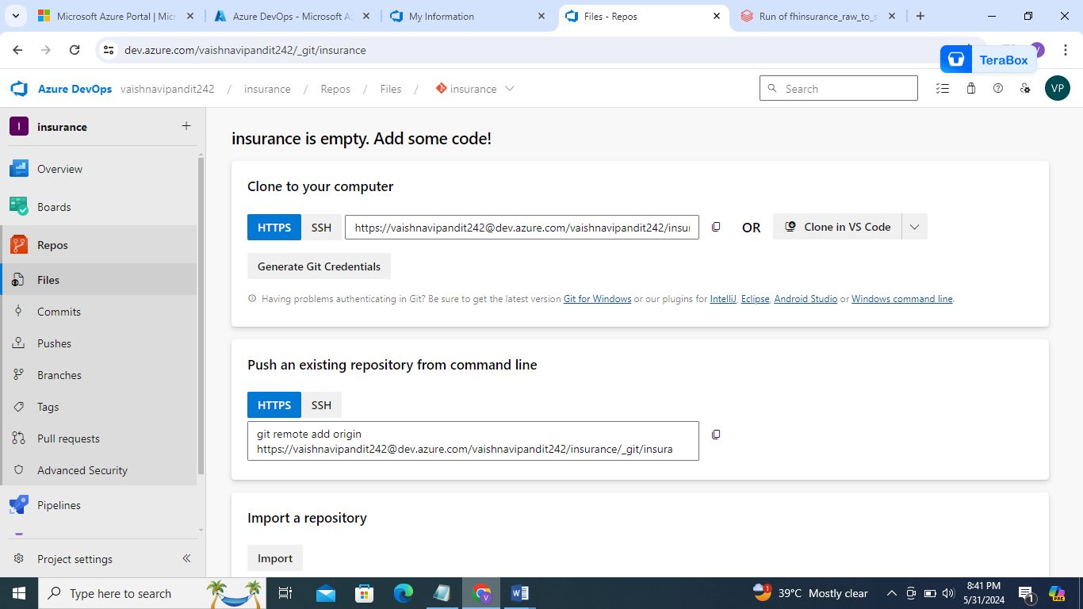

1. Go to databricks

->repos->add repos->paste url

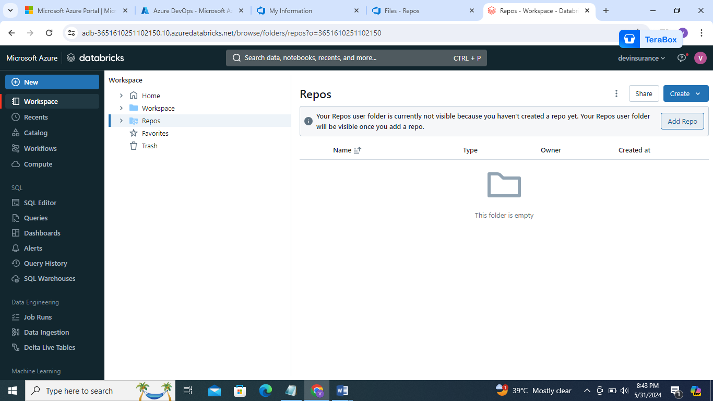

1. Paste url

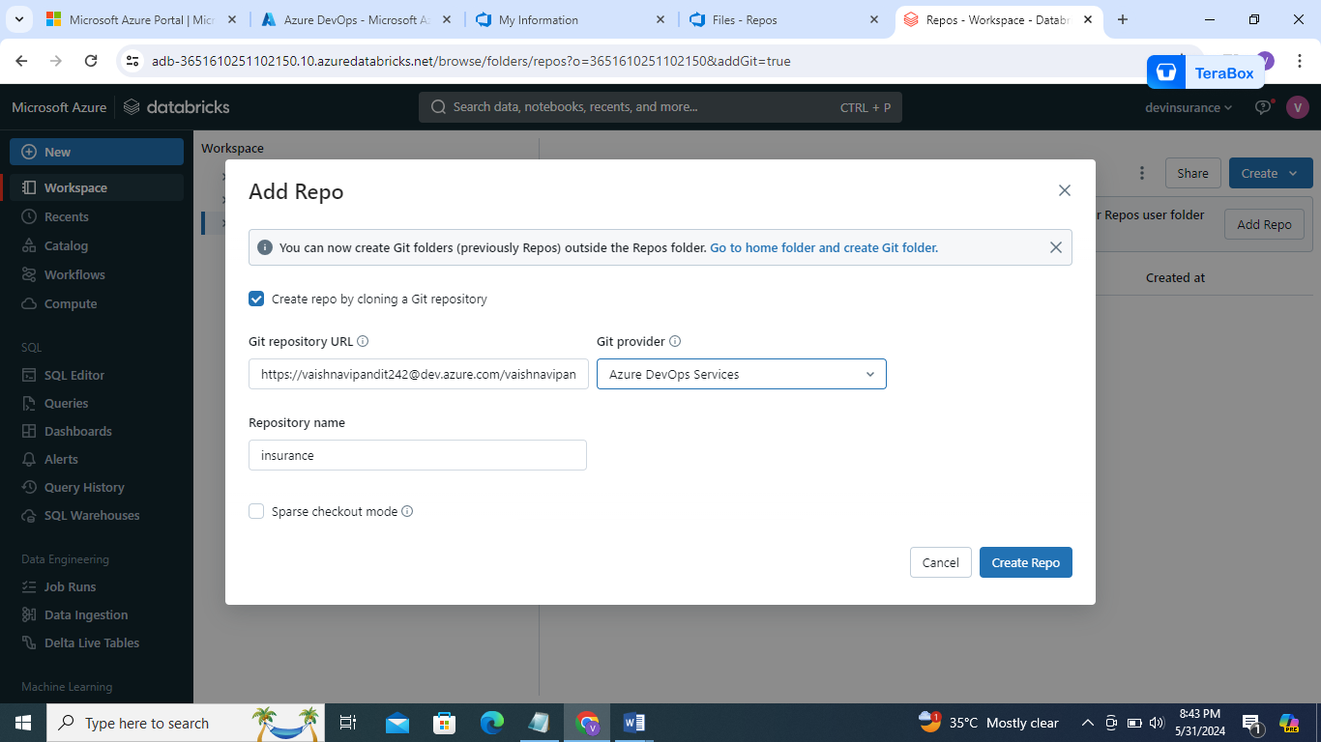

1. Go to azure devops on top right corner you will find user settings->go to personal access token

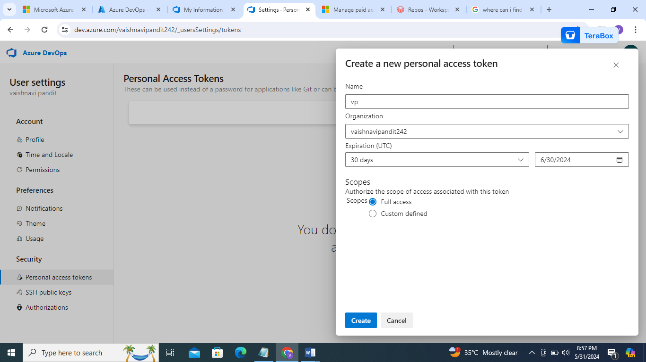

1. Create token
2. m3tjvg5t2geftklcn6ajkwbyrupid5iy3jll2tomr5fjyglqsn3a
3. copy the token you will not find it again

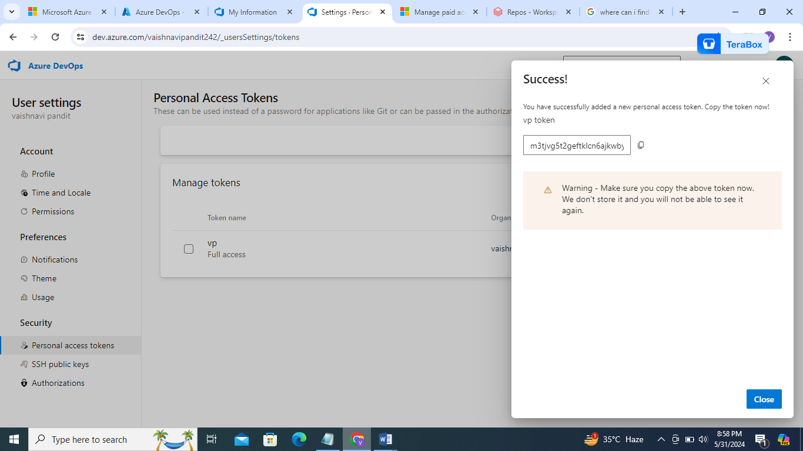

1. provide it in databricks

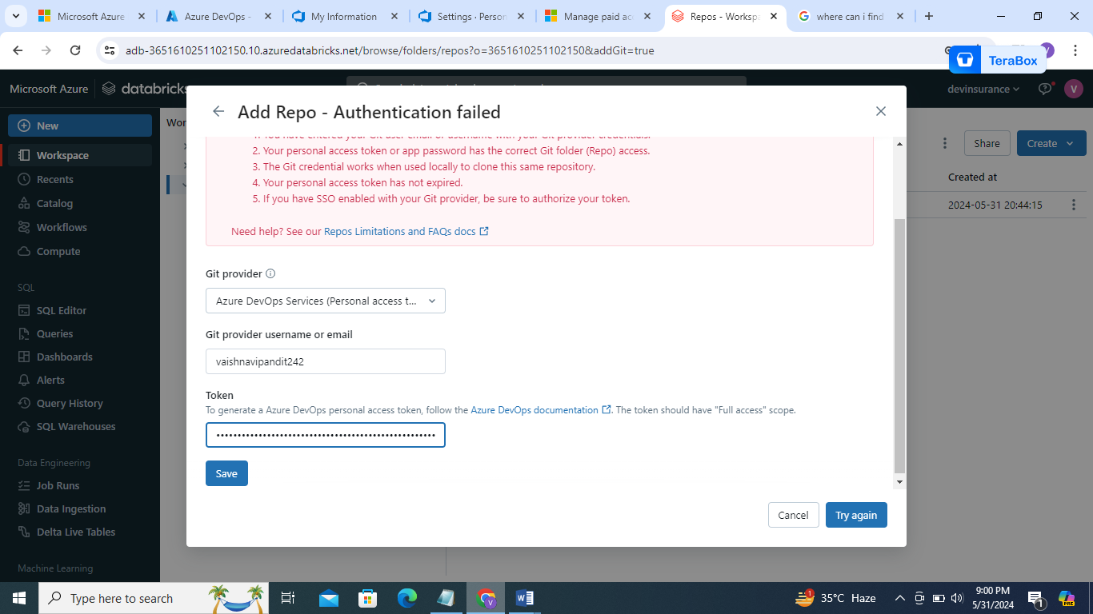

1. now create one more repo in insurance project
2. go to repos->files->click on insurance->create new repo

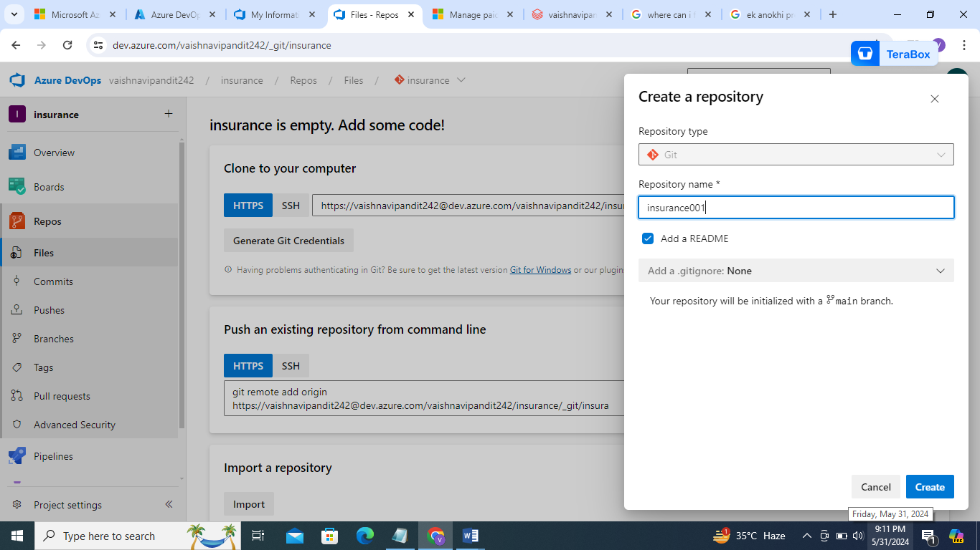

1. now clone it to databricks

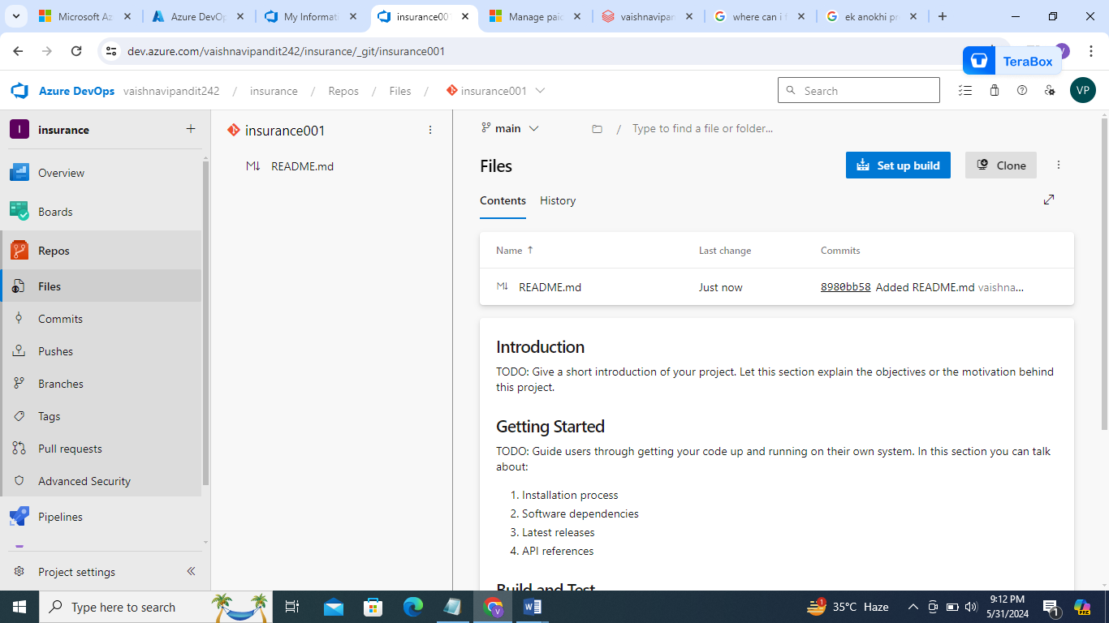

1. go to clone

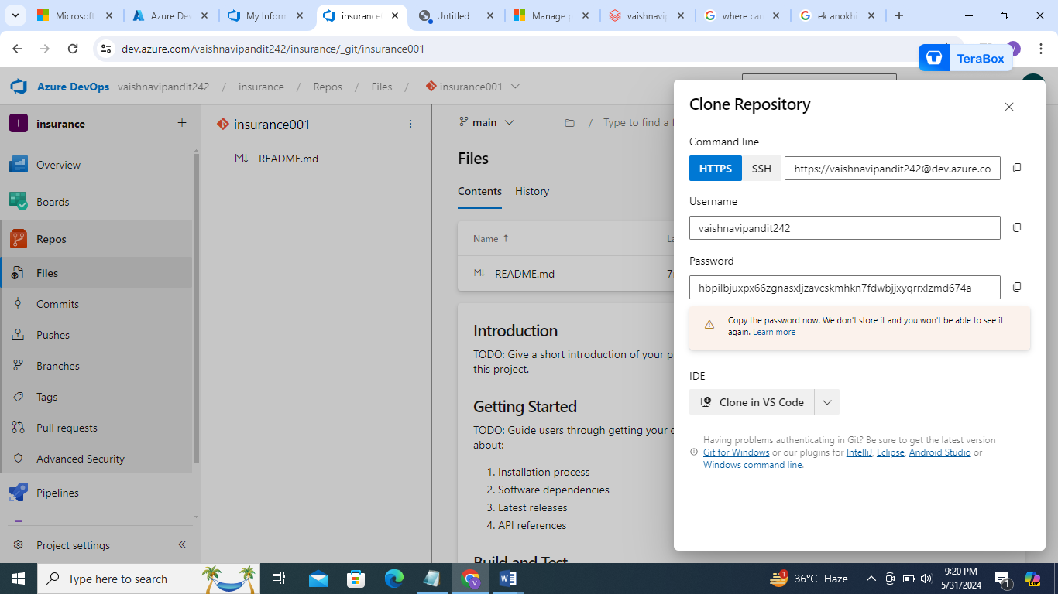

1. go to repos in dtabricks->go to repo->click on create->copy url and paste it in databricks

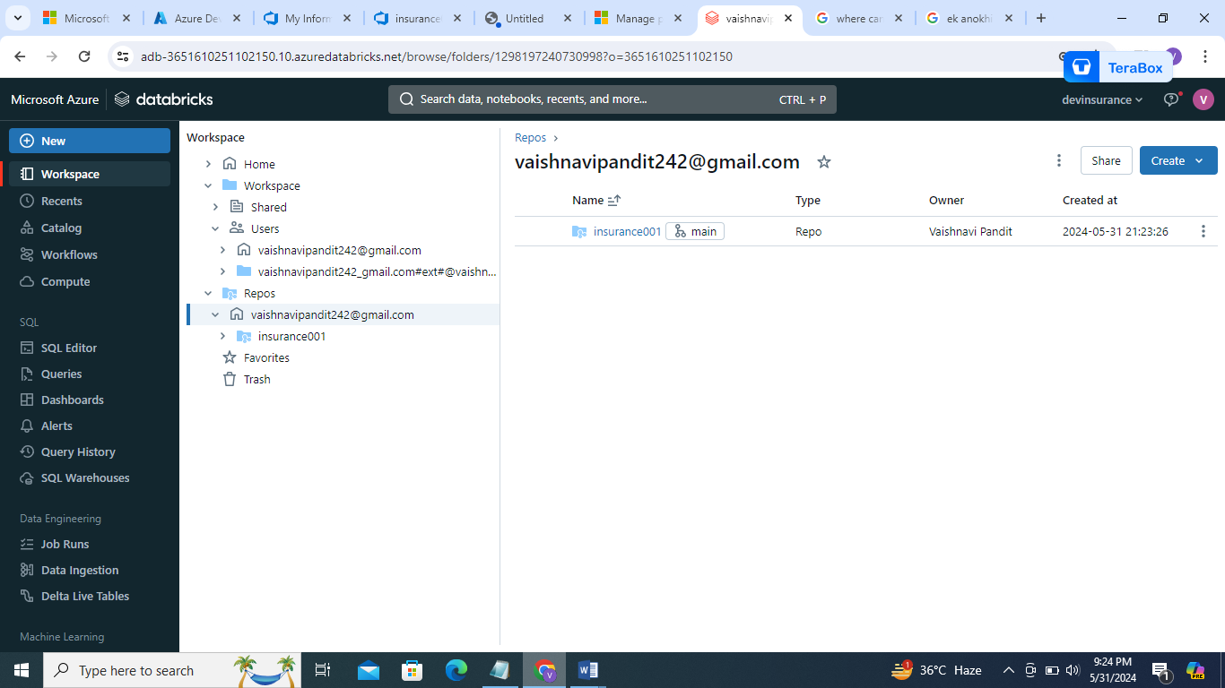

1. now move files in user to repo

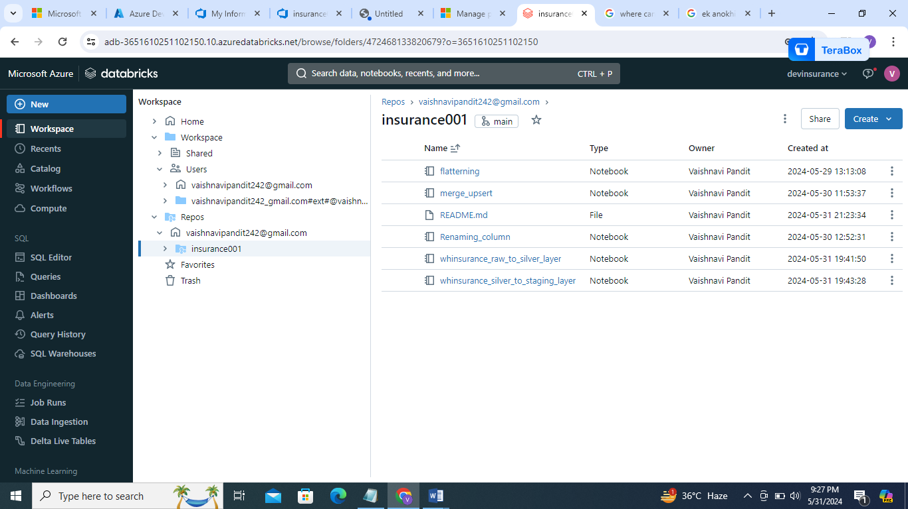

1. go to repo and click on main node

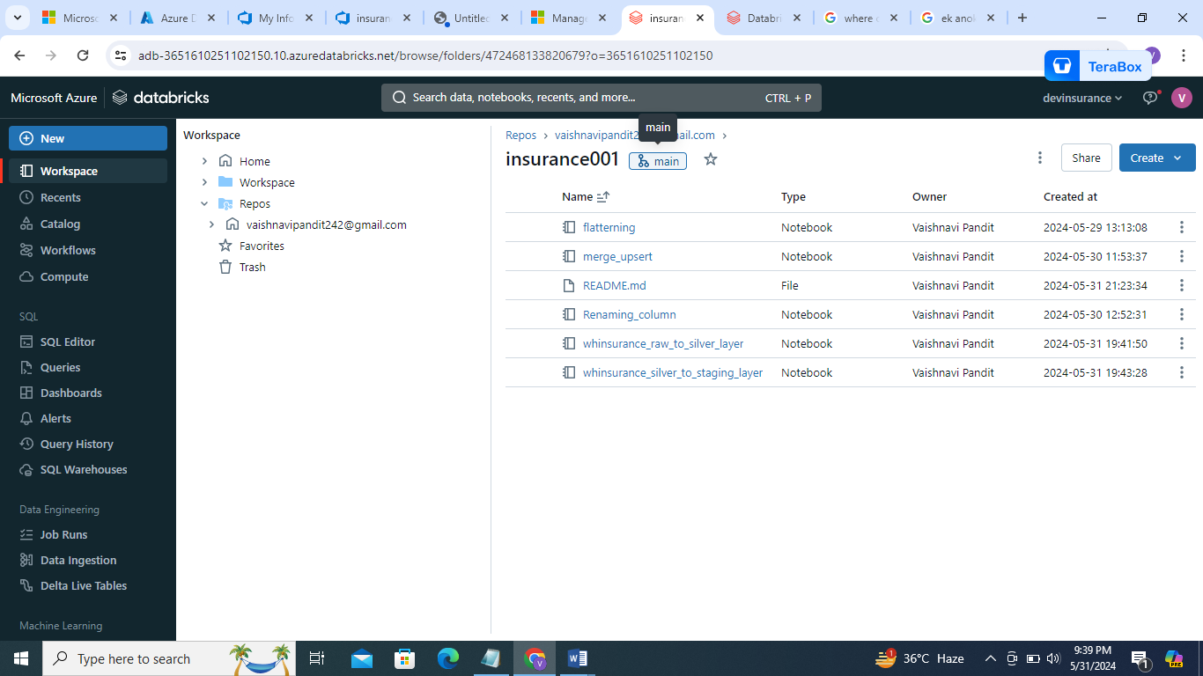

1. write commit message commit and push

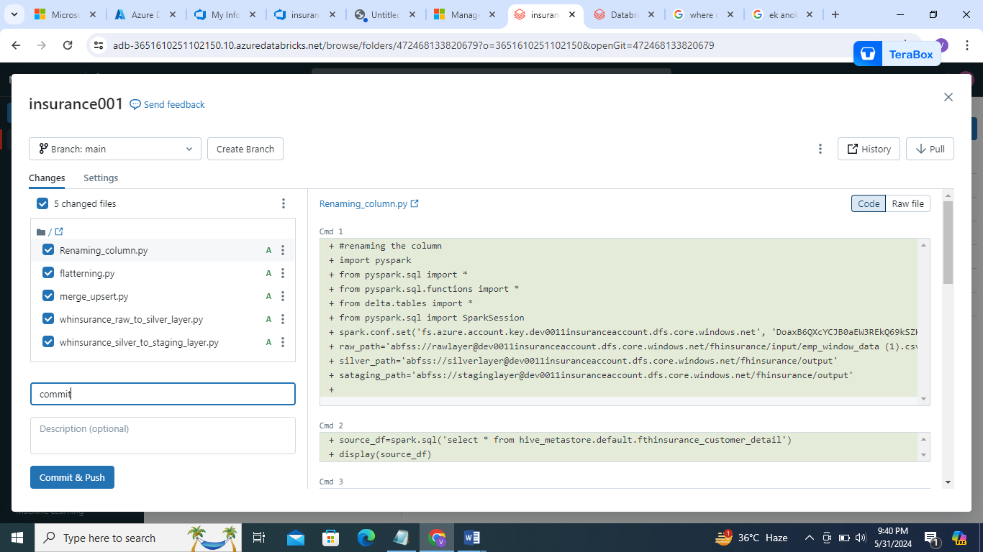

1. now go to azure devops create another branch because it is risky to directly commit on main branch

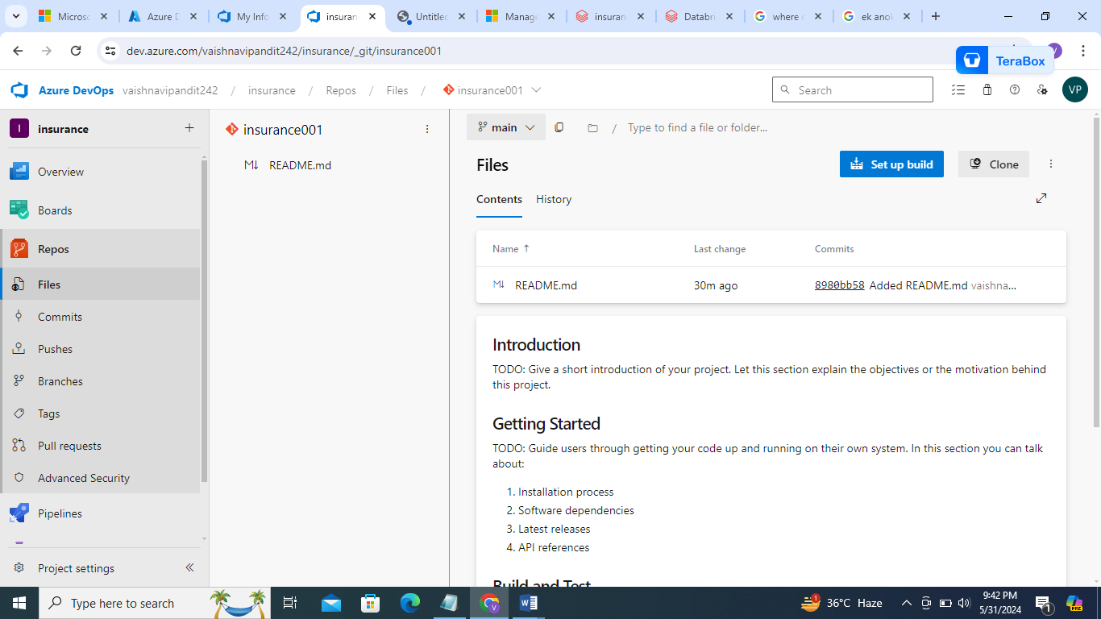

1. go to main in top

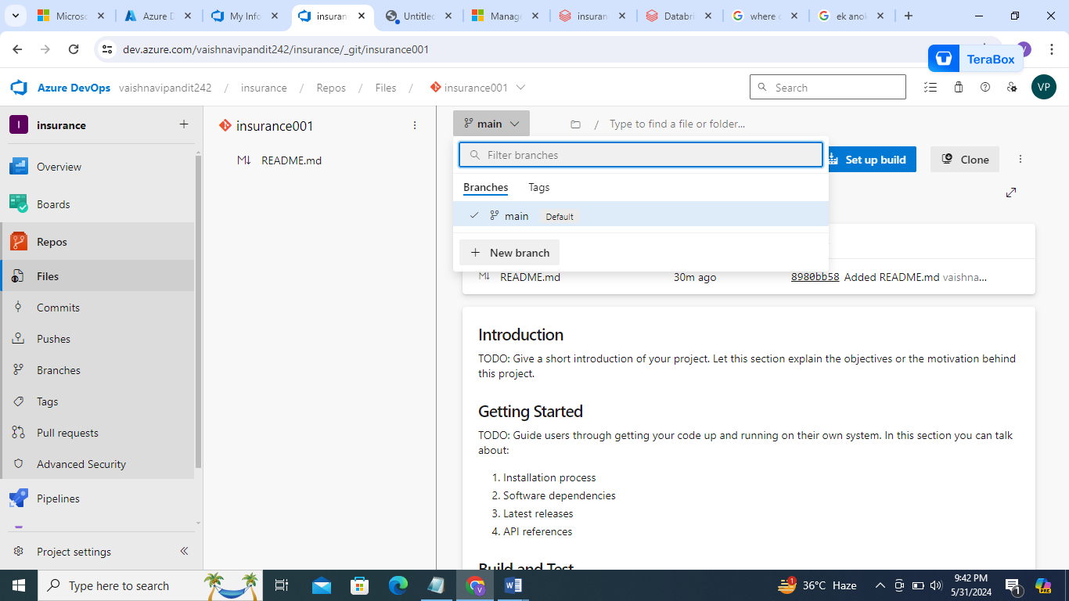

1. click on new branch

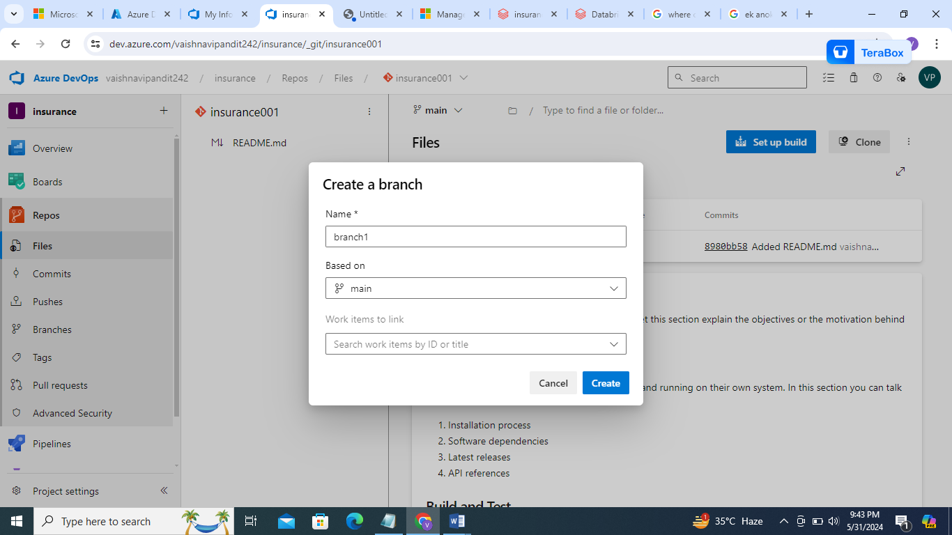

1. branch 1 created

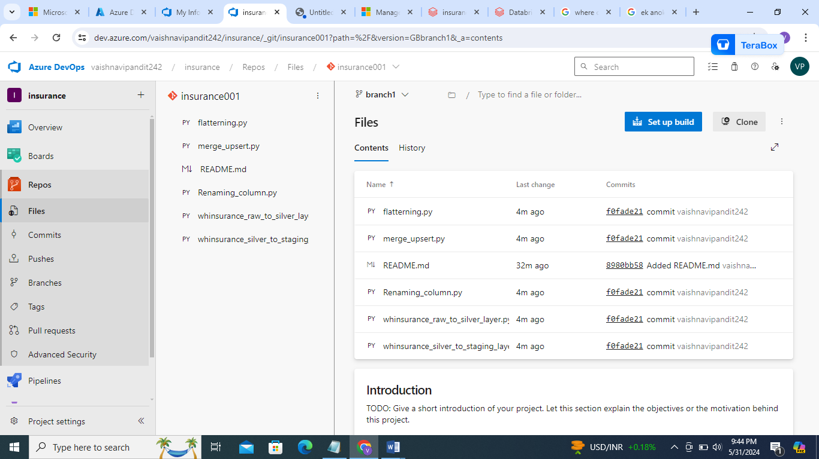

1. now go to databricks

go to main and change the branch

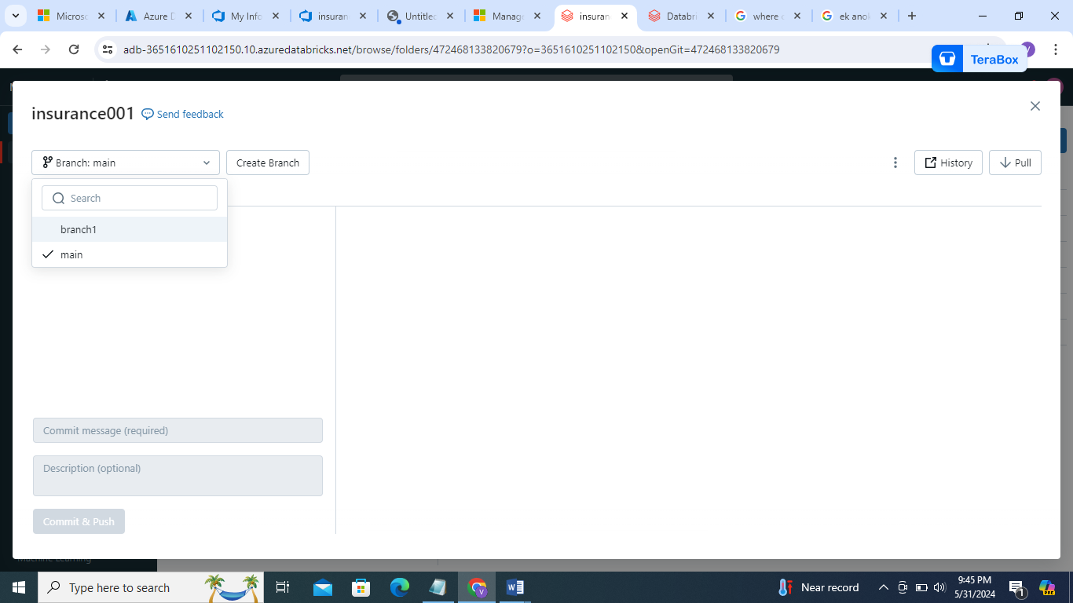

1. and commit to new branch
2. note don’t forget to change paths in job when you move notebooks from user to repo give paths of repo